Selection Sort
The basic operation here is key comparison,
A[j]<A[min].
The number of times, the basic operation is executed depends only on the array size and is given by,
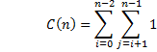
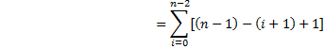
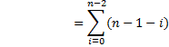

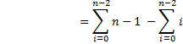

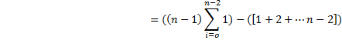
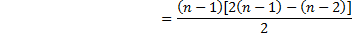
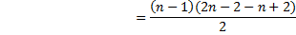
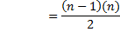
Therefore, C(n)

The number of key swaps is one for every iteration of the loop.ie. Ɵ(n) or (n-1)

